**Sprint 4 Plan, Detective Dollar**

Detective Dollar Team. Completion by Monday 11/27/23

**Goal:** This sprint’s main focus will be to refine the app’s UI design and implement and flesh out a few more features. We will also be focusing on some important bug fixes.

**Task Listing:**

User Story 1: As a user I can add a date to an expense.

1. Create back-end function for adding a date attribute to an expense entry (< 45 mins)
2. Implement front-end UI for adding a date to an expense to the “Add Expense” screen (< 1 hour)

Total for User Story: 1.75 hours

User Story 2: As a user I can edit an expense.

1. Create backend functions for modifying expenses (< 1 hour)
2. Create UI design for edit expense page (< 1 hour)
3. Implement front-end UI for editing expenses with functionality (< 2 hours)

Total for User Story: 4 hours

User Story 3: As a user, I can choose a color for a category. 12 default colors.

1. Create UI design for category color picking popup (< 1 hour)
2. Implement component for popup (< 2 hours)
3. Implement UI and functionality(< 1 hour)

Total for User Story: 4 hours

User Story 4: As a User, I can edit a recurring expense.

1. Create UI design for a new recurring expense page. (< 1 hour)
2. Implement necessary backend functions modifying recurring expenses (< 2 hours)
3. Implement new screen for editing recurring expenses, including means of navigation to said screen (< 1 hour)
4. Implement front-end UI for recurring expenses and functionality ( < 1 hour)

Total for User Story: 5 hours

**Team Roles:**

Thomas: Project Manager/Developer/ UX Designer

Hersh: UX Designer/Developer

Rohan: Developer

Ben: Scrum Master/Developer

Cecile: Developer

**Initial Task Assignment:**

Thomas ➡ Story: 1 Task: 2, Story: 2 Task 2, Story 3: Task: 1, Story: 4 Task: 1

* Non User story tasks: Reworking app UI. Bug fixes.

Hersh ➡ Story: 2 Task 2, Story 3: Task: 1, Story: 4 Tasks: 1, 3 4

* Non User story tasks: Reworking app UI. Bug fixes.

Rohan ➡ Story: 1 Task: 1, Story: 2 Task: 1, Story: 4 Task: 2

* Non User story tasks: Reworking app UI. Bug fixes.

Ben ➡ Story: 3 Tasks: 2, 3

* Non User story tasks: Reworking app UI. Bug fixes.

Cecile ➡ Story: 2 Task: 3

* Non User story tasks: Reworking app UI. Bug fixes.

**Initial Burnup Chart:**

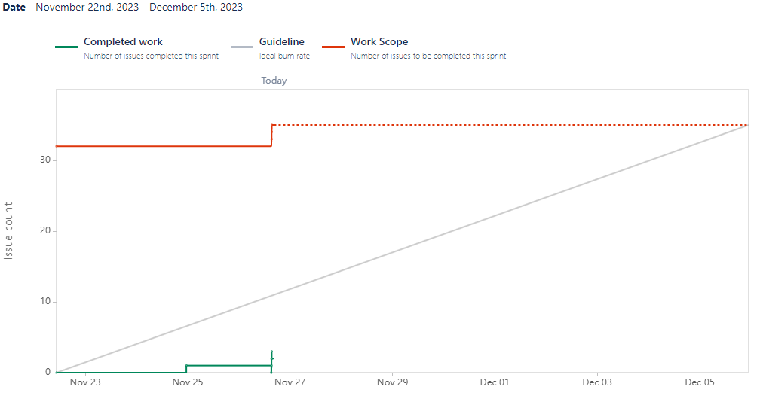

**Scrum Board:**

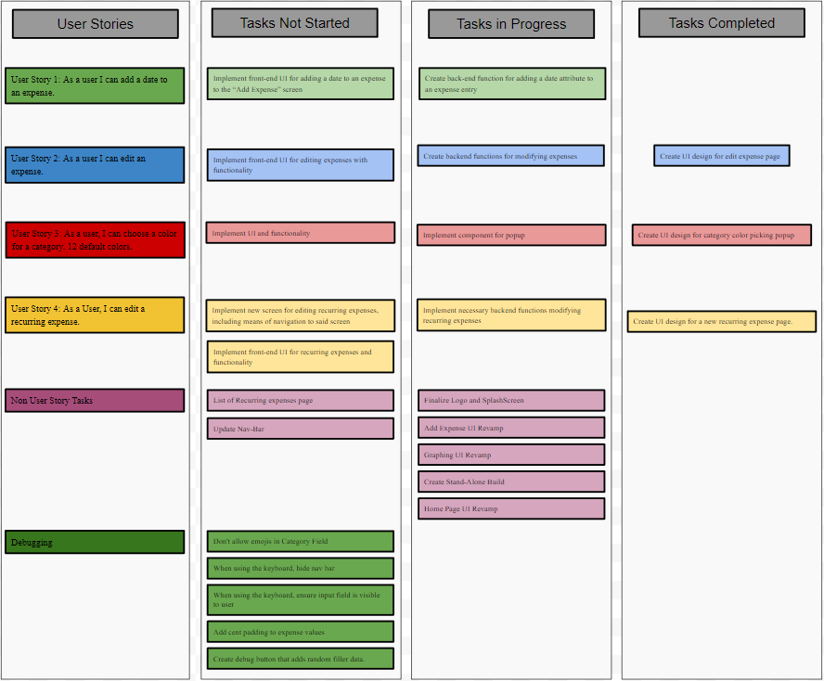

**Scrum Times:**

Mondays: 10am - 10:45 with TA

Thursdays: 4:15pm - 5:15pm

Sundays: 6pm - 7pm